Student Name: Mohammad Buhamad | Report No: 3
Student ID: 2240005142 | Date: 9/21/2025

- Task#1: Write a program to ask the user to enter two integers A and B and then display the result of computing the expression: A + 2B - 5.
Solution:
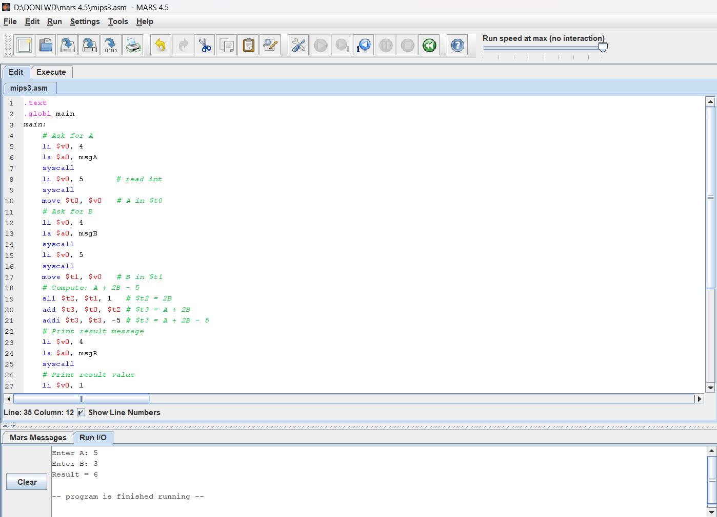
- Task#2: Assume that $s1 = 0x12345678 and $s2 = 0xffff9a00. Determine the content of registers $s3 to $s6 after executing the following instructions:
and $s3,$s1,$s2 # $s3 =
or $s4,$s1,$s2 # $s4 =
xor $s5,$s1,$s2 # $s5 =
nor $s6,$s1,$s2 # $s6 =
Write a program to execute these instructions and verify the content of registers $s3 to $s6.
Solution:
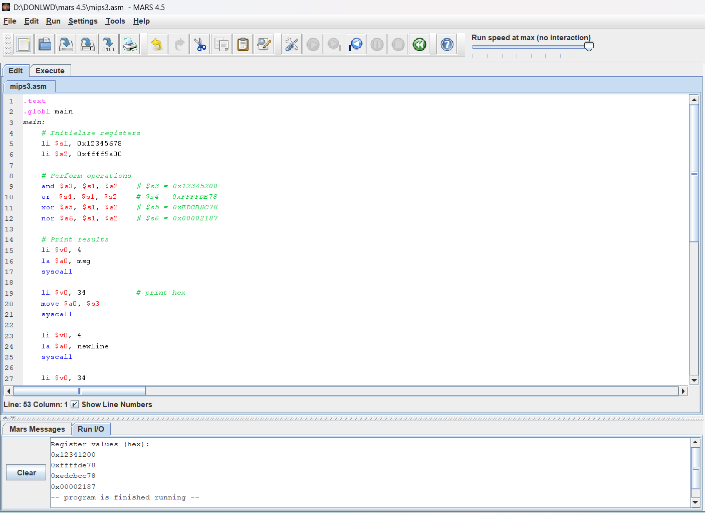
- Task#3: Assume that $s1 = 0x87654321. Determine the content of registers $s2 to $s4 after executing the following instructions:
sll $s2,$s1, 16 # $s2 =
srl $s3,$s1, 8 # $s3 =
sra $s4,$s1, 12 # $s4 =
Solution:
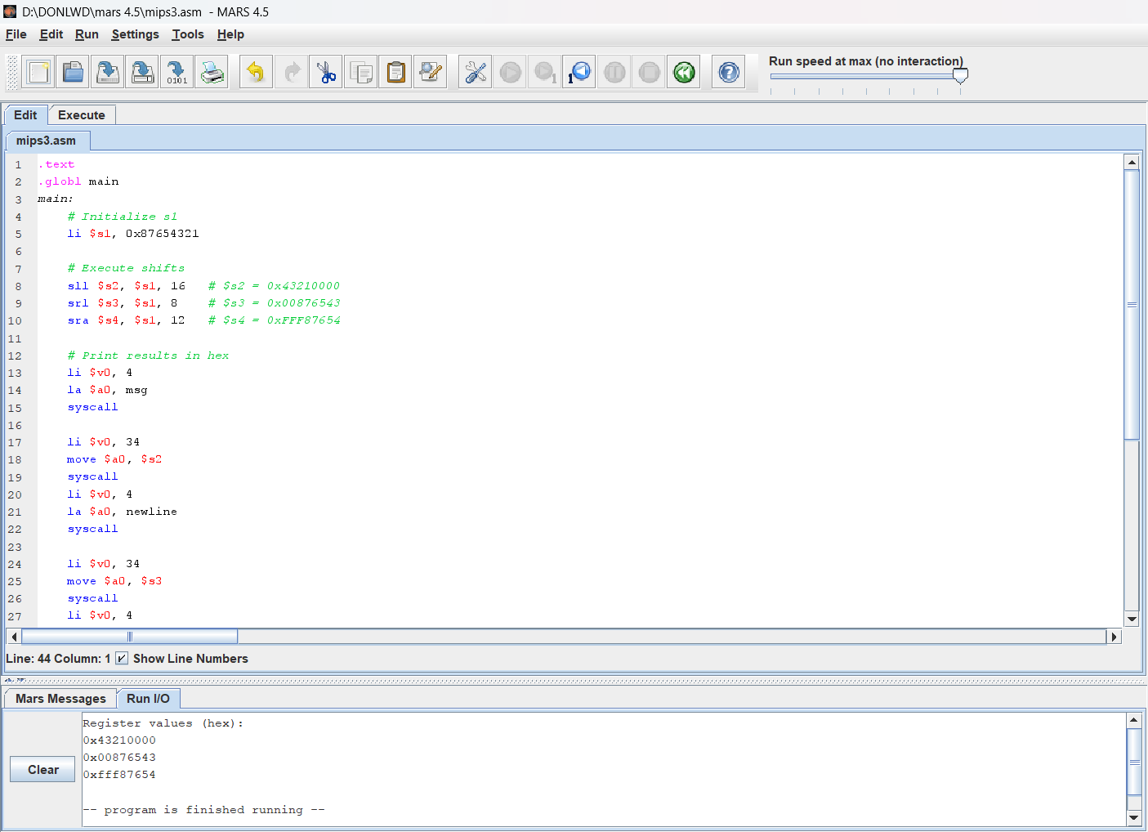
- Task#4: Write a program that asks the user to enter an alphabetic character (either lower or upper case) and change the case of the character from lower to upper and from upper to lower and display it.
Solution:
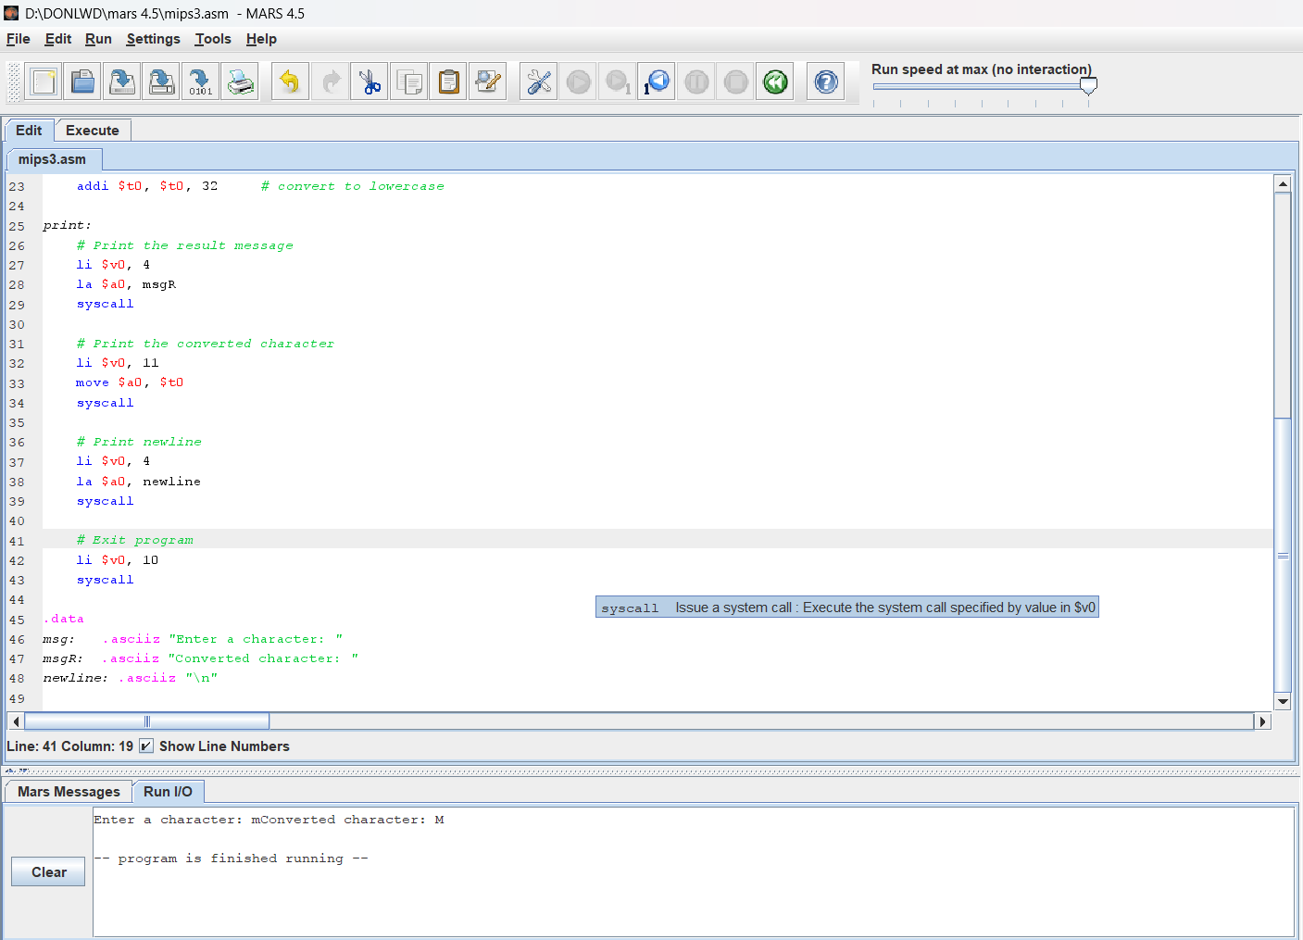
- Task#5: Write a program that asks the user to enter and integer number and read it. Then ask him to enter a bit position (between 0 and 31) and display the value of that bit.
srlv $s1,$s2,$s3
s2 = 32₁₀ = 0000 0000 0000 1000 0000 0000 010 0000₂
s3 = 18
Bit = 10

1 = 00000000000000000000000000010000
2 = 00000000000000000000000000001000
3 = 00000000000000000000000000000100
4 = 00000000000000000000000000000010
5 = 00000000000000000000000000000001
S1 = 00000000000000000000000000000001
1 = 00000000000000000000000000000001
$t0 = 00000000000000000000000000000001 =
x.1 = x
AND $t0,$s1,1
Solution:
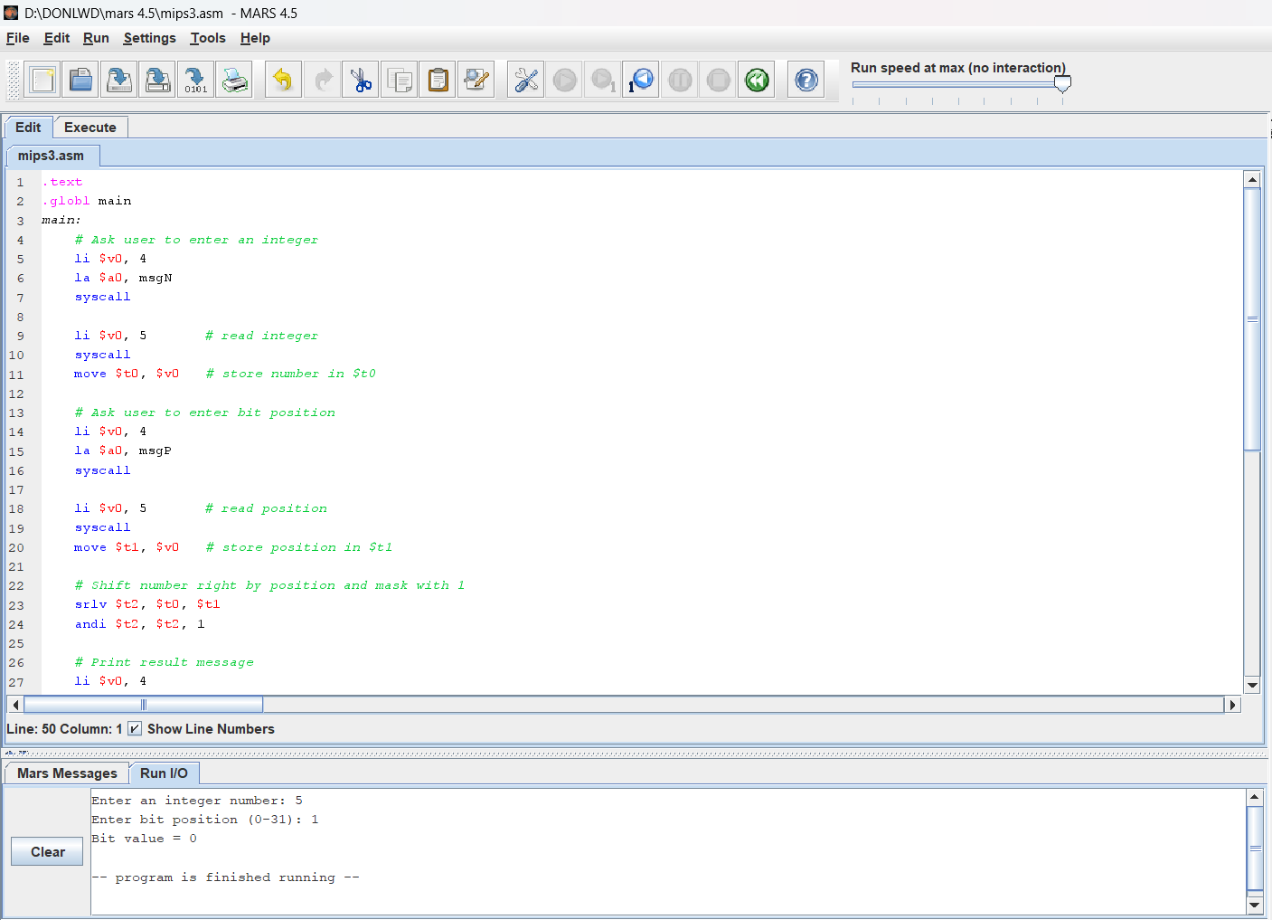
Task#6: Write a program that asks the user to enter a signed number and read it. Then display the content of multiplying this number by 24.5.
Solution:
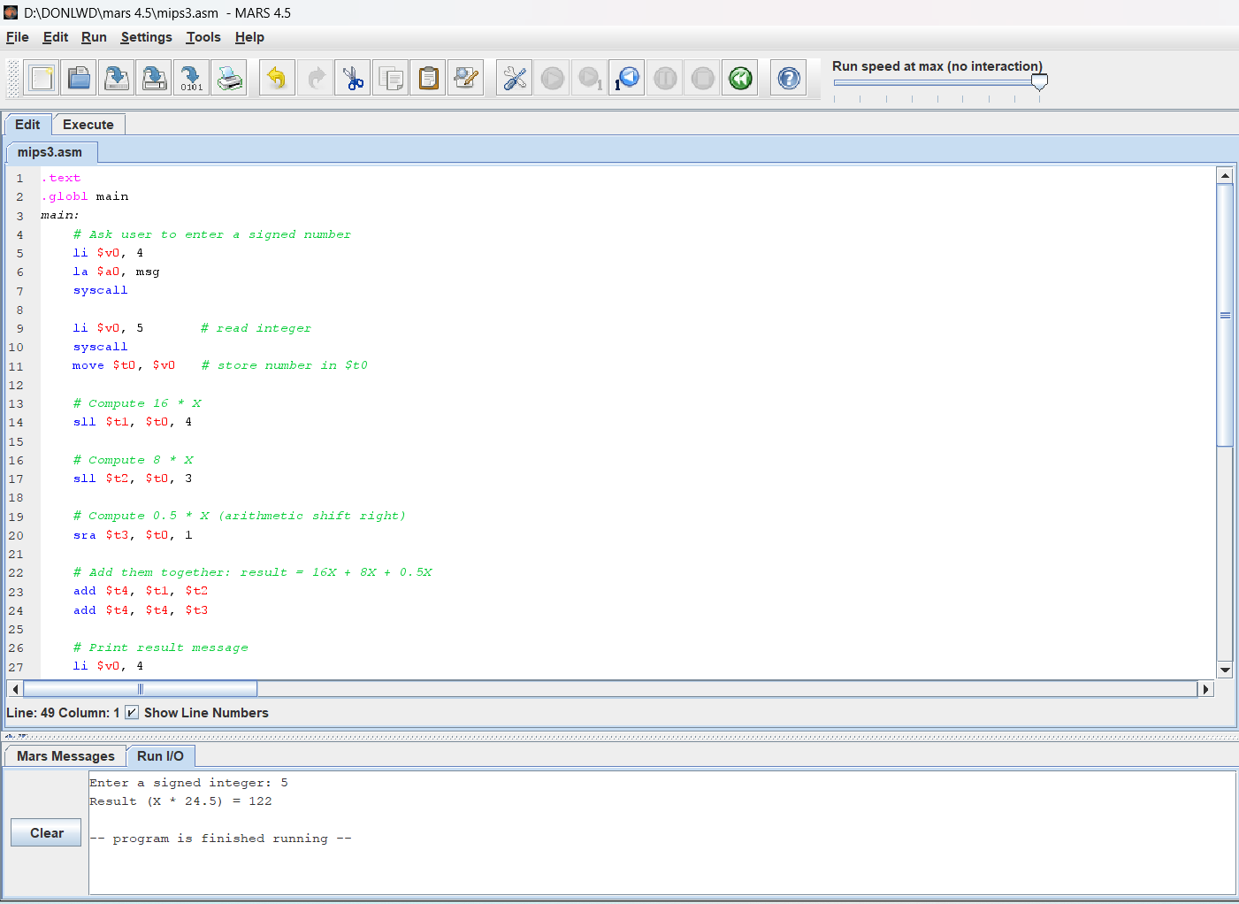
- Task#7: Write a program that asks the user to enter an unsigned number and read it. Then swap the bits at odd positions with those at even positions and display the resulting number. For example, if the user enters the number 9, which has binary representation of 1001, then bit 0 is swapped with bit 1, and bit 2 is swapped with bit 3, resulting in the binary number 0110. Thus, the program should display 6.
Solution:
